This class assignment is designed to deepen your understanding of methods by writing a series of methods. The base code has been given to you for each of these methods. It is up to you to answer the four questions and create the methods to complete the sketch.

* DO NOT CHANGE THE CODE GIVEN TO YOU*

**Information Methods**

**flatten()** – this method relies on the fact that an integer divided by an integer returns an integer. So 237 / 100 * 100 is actually 200! (237 / 100 = 2 then 2 * 100 = 200). This idea lets us turn a picture with many different colors into one with less colors. Your job is to write the **flatten()** method. It takes in two numbers and returns the result when you divide the first number by the second number then take the result of the division and multiply it by the second number. If done correctly, you will see the picture on the left turn into the picture on the right when you click the mouse.

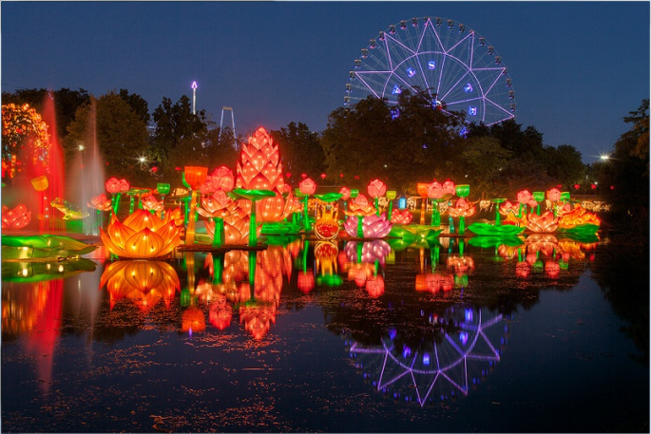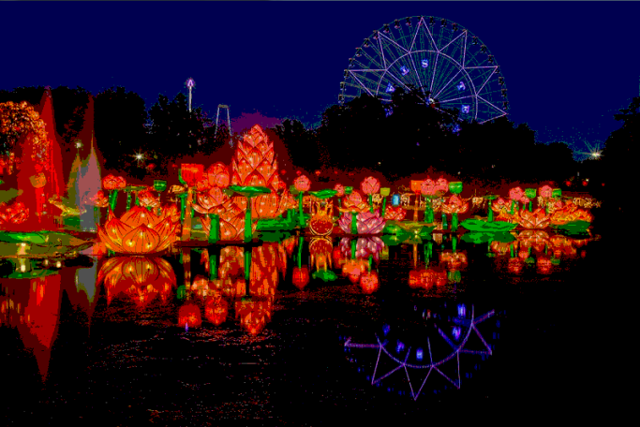

**distance()** – this method calculates the distance between two points. NO – YOU MAY NOT USE THE **dist()** METHOD. Write your own! When written correctly, your sketch will draw a small white circle somewhere on the screen, draw a line from the circle to the mouse, and display the distance between the two. Remember **sqrt()** and **pow()** are information methods used to calculate square roots and powers.

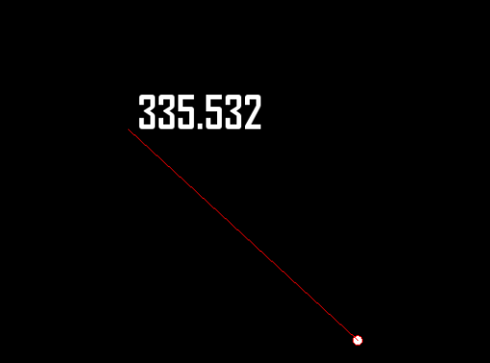

**average()** – this method will calculate the average of three values sent to it. The challenge with this program is you are asked not only to write the **average()** method, but to use other information methods like **red()**, **green()**, and **blue()** to determine the RGB values of a particular pixel. Follow the steps in the sketch, and your program should take our red warrior logo and turn it black and white.

